
Patan College For Professional Studies Kupondole, Kathmandu

Assignment 1 – Aspire Fitness – Database Design
Course ID: CIS095-1

Submitted by : Swodesh Singh
University ID: 2533510
Table of Contents
Introduction 3
Scenario Description 3
Assumptions 3
Entity Relationship Model 3
The Entities 3
The Relationships 4
The Entity Relationship Diagram 5
Physical Database Design 6
Choice of DBMS 6
Skeleton Tables 6
Data Dictionary 6
Implementation of Database 9
Create Tables 9
Table1: Member Table 9
Table2: Staff Table 10
TABLE 3: FACILITY 11
TABLE 4: CLASS 11
Table 5: Class_Booking 12
Table 6: FACILITY_BOOKING 14
Table 7: PAYMENT 15
Insert Data 16
Members 16
Staff 17
Facility 17
Class 18
CLASS_BOOKING 19
FACILITY_BOOKING 19
Payment 20
Query Design and Implementation 21
List of Queries Purpose 21
Querry1 21
Querry2 21
Querry3 22
Querry4 22
Querry5 23
Querry6 23
Querry7 24
Discussion / Critical Reflection 24
Conclusion 25

Table 1 Table of Entities 6
Table 2 Data dictionary Member 9
Table 3 Data dictionary Staff 9
Table 4 Data dictionary Class 9
Table 5 Data dictionary Facility 10
Table 6 Data dictionary Class_Booking 10
Table 7 Data dictionary Facility_Booking 10
Table 8 Data dictionary Payment 11
Table 9 Querry purpose 23

Figure 1 Member table creation 12
Figure 2 Staff table creation 13
Figure 3 Facility table creation 13
Figure 4 Class table creation 14
Figure 5 Class_Booking table creation 15
Figure 6 Facility_Booking table creation 17
Figure 7 Payment table creation 18
Figure 8 Values inserted in Member 19
Figure 9 Values inserted in Staff 19
Figure 10 Values inserted in Facility 20
Figure 11 Values inserted in Class 20
Figure 12 Values inserted in Class_Booking 21
Figure 13 Values inserted in Facility_Booking 22
Figure 14 Values inserted in Payment 22
Figure 15 Querry: List all active members 23
Figure 16 Querry: Show all classes taught by a specific instructor 24
Figure 17 Querry: Count the number of bookings per class 24
Figure 18 Querry: Find members who have booked classes in a given week 25
Figure 19 Querry: List all facility bookings for a given week 25
Figure 20 Querry: Calculate total revenue by payment type 26
Figure 21 Querry: Retrieve classes that still have availability 26

Introduction
This assignment will entail the development and implementation of a relational database system for a hypothetical fitness club, referred to as Aspire Fitness. This report will outline the process of designing the database, which will include the physical, conceptual, and implementation stages, and finally the SQL queries to validate the functionality of the system, with the process being reflected on.

Scenario Description
Aspire Fitness is a fitness club, and the members pay a subscription fee to attend the classes and rent the facilities, such as courts and rooms. The members can book the classes or facilities, and the staff manage the classes. This system has to keep track of the members, staff, and bookings to manage the fitness club effectively.

Assumptions
- The following assumptions were made during the design process:
- A week is defined between Monday and Sunday, with support for weekly limits defined in the booking_week generated column.
- British Pounds (£) is used for all financial transactions, and time is represented in MySQL’s 24-hour TIME format.
- New members start with an ACTIVE status by default but can be changed if they leave or are removed.
- Facilities must be marked as “hireable” to be bookable. There is only one instructor per class but multiple classes per staff member. There can be multiple payments and subscriptions involved in a payment, and receipt numbers are generated by the system. Medical conditions are only for reference.

Entity Relationship Model
An Entity Relationship Model (ERM) is employed to design the structure of a database system. It identifies the entities involved in the system, the attributes of the entities, and the relationships between the entities.
The ER model for Aspire Fitness is designed based on the reference diagram provided in the assignment.

The Entities
The main entities identified in the Aspire Fitness database system include:
Entity | Description
Member | Stores personal information about registered club members.
Staff | Stores details about employees such as instructors and trainers.
Class | Stores information about scheduled fitness classes.
Facility | Stores details of the physical facilities available for booking.
Class Booking | Records which members have booked particular classes.
Facility Booking | Records facility reservations made by members.
Payment | Stores payment transactions made by members.
Table 1 Table of Entities

Each has attributes that hold certain information about the entity in question. For instance, the Member entity has attributes like member ID, first name, surname, address, phone number, email, and so forth.

The Relationships
There are several relationships between the entities in the Aspire Fitness system.
A Staff member has a relationship with Classes in the sense that a member of staff can teach several classes but a class is only taught by a single member of staff.
Members can book Classes in the system. This creates a many-to-many relationship between the Members and Classes entities. This relationship is resolved through the Class_Booking table.
Members can also book Facilities in the system for activities such as sport and training.
The Facility entity has a relationship with the Facility_Booking table because the booking has to be for a specific facility.
Members can also make Payments in the system. This records the financial transactions involved in the subscription fees.
These relationships ensure that the database structure correctly reflects the operations of the Aspire Fitness organization.

The Entity Relationship Diagram
The ER diagram is a graphical representation of data in a system, including objects or entities and their associated qualities or attributes, as well as how they interact with each other through relationships. It is created with a database modeling tool based on relational database design methodologies.
The entities or main objects on the diagram are Member, Staff, Class, Facility, Class_Booking, Facility_Booking, and Payment.
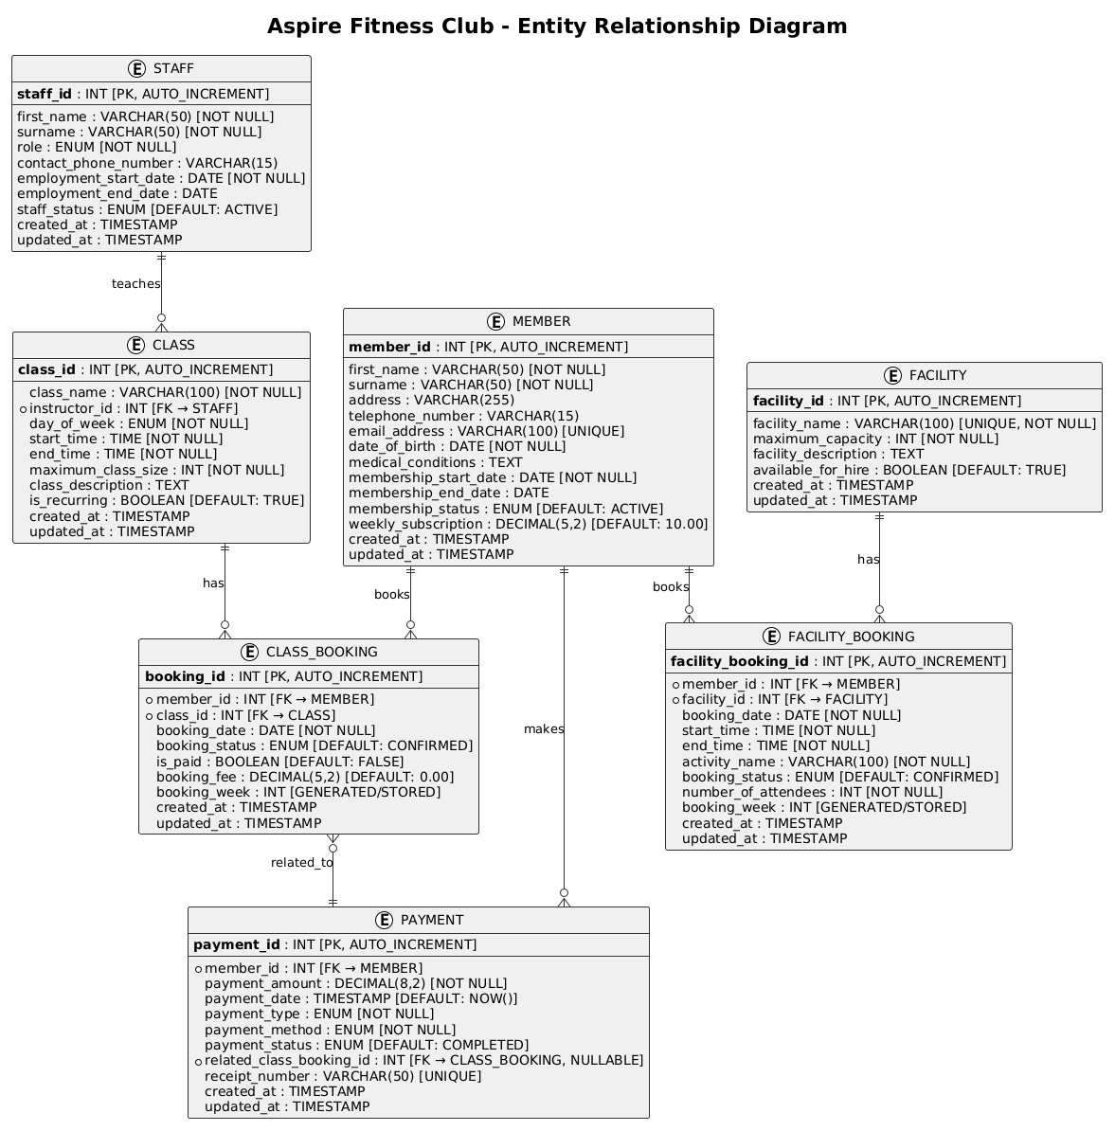

Physical Database Design

Choice of DBMS
MySQL has been selected as the Database Management System for this project. MySQL is an open-source RDBMS system known for its reliability and simplicity. MySQL is highly suitable for web-based applications and academic projects. MySQL has robust support for standard SQL and transactional integrity (ACID properties), and foreign key constraints are highly suitable for implementing the Aspire Fitness relational model in a secure and efficient manner.

Skeleton Tables
The logical entities were converted into the following relational tables.
Member (member_id, first_name, surname, address, telephone_number, email_address, date_of_birth, membership_start_date, membership_status)
Staff (staff_id, first_name, surname, role, contact_phone_number)
Class (class_id, class_name, instructor_id, day_of_week, start_time, end_time, maximum_class_size)
Facility (facility_id, facility_name, maximum_capacity)
Class_Booking (booking_id, member_id, class_id, booking_date, booking_status)
Facility_Booking (facility_booking_id, member_id, facility_id, booking_date, start_time, end_time)
Payment (payment_id, member_id, payment_amount, payment_date, payment_method)
Primary keys uniquely identify each record while foreign keys maintain relationships between tables.

Data Dictionary
Member Table
Field Name | Datatype | Description
member_id (PK) | INT | Unique identifier for each member
first_name | VARCHAR(50) | Member first name
surname | VARCHAR(50) | Member last name
address | VARCHAR(150) | Member home address
telephone_number | VARCHAR(15) | Member contact number
email_address | VARCHAR(100) | Member email
date_of_birth | DATE | Member birth date
medical_conditions | VARCHAR(200) | Any medical conditions
Table 2 Data dictionary Member
Staff Table
Field Name | Datatype | Description
staff_id (PK) | INT | Unique identifier for staff
first_name | VARCHAR(50) | Staff first name
surname | VARCHAR(50) | Staff last name
role | VARCHAR(50) | Job role (trainer, instructor, manager etc.)
contact_phone_number | VARCHAR(15) | Staff contact number
Table 3 Data dictionary Staff
Class Table
Field Name | Datatype | Description
class_id (PK) | INT | Unique class identifier
class_name | VARCHAR(50) | Name of the class
instructor_id (FK) | INT | Staff member teaching the class
day_of_week | VARCHAR(10) | Day the class is held
start_time | TIME | Class start time
end_time | TIME | Class end time
maximum_class_size | INT | Maximum number of participants
Table 4 Data dictionary Class
Facility Table
Field Name | Datatype | Description
facility_id (PK) | INT | Unique facility identifier
facility_name | VARCHAR(50) | Name of the facility
maximum_capacity | INT | Maximum number of users allowed
Table 5 Data dictionary Facility
Class_Booking Table
Field Name | Datatype | Description
booking_id (PK) | INT | Unique class booking ID
member_id (FK) | INT | Member making the booking
class_id (FK) | INT | Class being booked
booking_date | DATE | Date the booking was made
booking_status | VARCHAR(20) | Status of booking
Table 6 Data dictionary Class_Booking
Facility_Booking Table
Field Name | Datatype | Description
facility_booking_id (PK) | INT | Unique facility booking ID
member_id (FK) | INT | Member making the booking
facility_id (FK) | INT | Facility being booked
booking_date | DATE | Date of facility booking
start_time | TIME | Booking start time
end_time | TIME | Booking end time
Table 7 Data dictionary Facility_Booking
Payment Table
Field Name | Datatype | Description
payment_id (PK) | INT | Unique payment identifier
member_id (FK) | INT | Member making the payment
payment_amount | DECIMAL(8,2) | Amount paid
payment_date | DATE | Date payment was made
payment_method | VARCHAR(20) | Payment type (cash, card, online)
Table 8 Data dictionary Payment

Implementation of Database

Create Tables

Table1: Member Table
CREATE TABLE MEMBER (
member_id INT AUTO_INCREMENT PRIMARY KEY,
first_name VARCHAR(50) NOT NULL,
surname VARCHAR(50) NOT NULL,
address VARCHAR(255),
telephone_number VARCHAR(15),
email_address VARCHAR(100) UNIQUE,
date_of_birth DATE NOT NULL,
medical_conditions TEXT,
membership_start_date DATE NOT NULL,
membership_end_date DATE,
membership_status ENUM('ACTIVE', 'INACTIVE', 'SUSPENDED') DEFAULT 'ACTIVE',
weekly_subscription DECIMAL(5,2) DEFAULT 10.00,
created_at TIMESTAMP DEFAULT CURRENT_TIMESTAMP,
updated_at TIMESTAMP DEFAULT CURRENT_TIMESTAMP ON UPDATE CURRENT_TIMESTAMP,
INDEX idx_member_status (membership_status),
INDEX idx_email (email_address)
) ENGINE=InnoDB DEFAULT CHARSET=utf8mb4 COLLATE=utf8mb4_unicode_ci;
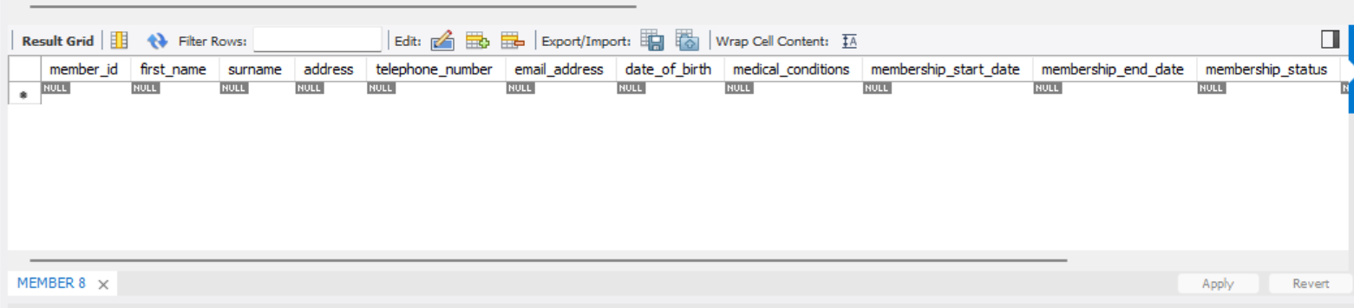
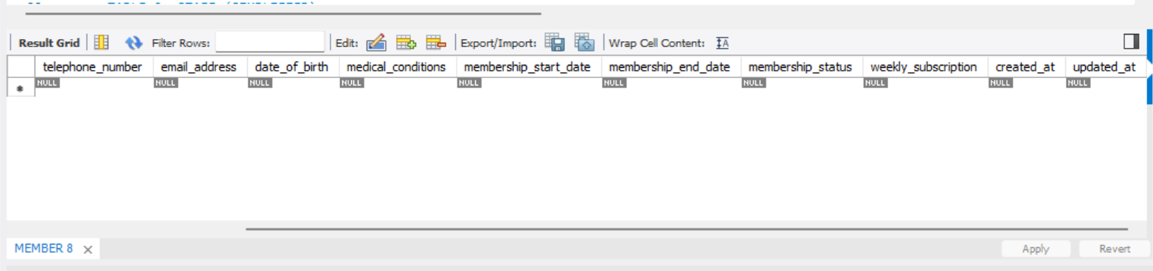
Figure 1 Member table creation

Table2: Staff Table
CREATE TABLE STAFF (
staff_id INT AUTO_INCREMENT PRIMARY KEY,
first_name VARCHAR(50) NOT NULL,
surname VARCHAR(50) NOT NULL,
role ENUM('Personal Trainer', 'Class Instructor', 'Gym Staff', 'Manager', 'Administration') NOT NULL,
contact_phone_number VARCHAR(15),
employment_start_date DATE NOT NULL,
employment_end_date DATE,
staff_status ENUM('ACTIVE', 'INACTIVE') DEFAULT 'ACTIVE',
created_at TIMESTAMP DEFAULT CURRENT_TIMESTAMP,
updated_at TIMESTAMP DEFAULT CURRENT_TIMESTAMP ON UPDATE CURRENT_TIMESTAMP,
INDEX idx_role (role),
INDEX idx_staff_status (staff_status)
) ENGINE=InnoDB DEFAULT CHARSET=utf8mb4 COLLATE=utf8mb4_unicode_ci;
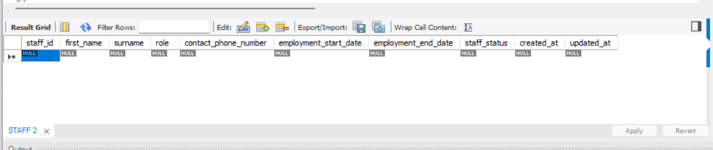
Figure 2 Staff table creation

TABLE 3: FACILITY
CREATE TABLE FACILITY (
facility_id INT AUTO_INCREMENT PRIMARY KEY,
facility_name VARCHAR(100) UNIQUE NOT NULL,
maximum_capacity INT NOT NULL,
facility_description TEXT,
available_for_hire BOOLEAN DEFAULT TRUE,
created_at TIMESTAMP DEFAULT CURRENT_TIMESTAMP,
updated_at TIMESTAMP DEFAULT CURRENT_TIMESTAMP ON UPDATE CURRENT_TIMESTAMP,
CHECK (maximum_capacity > 0),
INDEX idx_facility_name (facility_name)
) ENGINE=InnoDB DEFAULT CHARSET=utf8mb4 COLLATE=utf8mb4_unicode_ci;
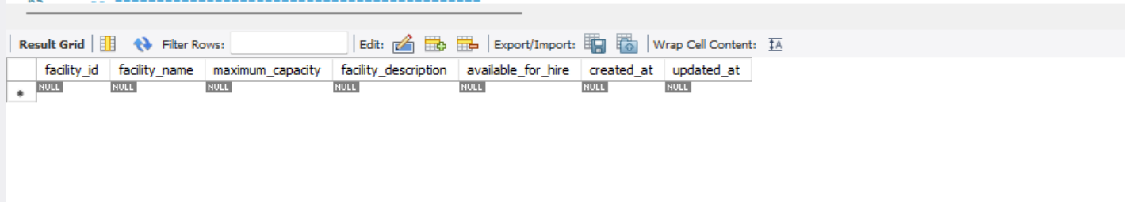
Figure 3 Facility table creation

TABLE 4: CLASS
CREATE TABLE CLASS (
class_id INT AUTO_INCREMENT PRIMARY KEY,
class_name VARCHAR(100) NOT NULL,
instructor_id INT NOT NULL,
day_of_week ENUM('Monday', 'Tuesday', 'Wednesday', 'Thursday', 'Friday', 'Saturday', 'Sunday') NOT NULL,
start_time TIME NOT NULL,
end_time TIME NOT NULL,
maximum_class_size INT NOT NULL,
class_description TEXT,
is_recurring BOOLEAN DEFAULT TRUE,
created_at TIMESTAMP DEFAULT CURRENT_TIMESTAMP,
updated_at TIMESTAMP DEFAULT CURRENT_TIMESTAMP ON UPDATE CURRENT_TIMESTAMP,
FOREIGN KEY (instructor_id) REFERENCES STAFF(staff_id),
CHECK (maximum_class_size > 0),
CHECK (end_time > start_time),
UNIQUE KEY unique_class_schedule (instructor_id, day_of_week, start_time, end_time),
INDEX idx_instructor_id (instructor_id),
INDEX idx_day_of_week (day_of_week)
) ENGINE=InnoDB DEFAULT CHARSET=utf8mb4 COLLATE=utf8mb4_unicode_ci;
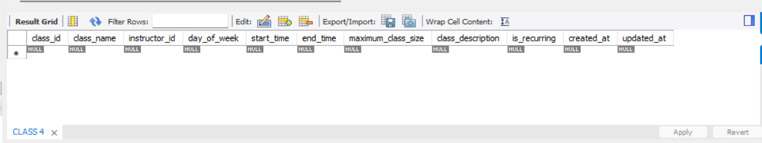
Figure 4 Class table creation

Table 5: Class_Booking
CREATE TABLE CLASS_BOOKING (
booking_id INT AUTO_INCREMENT PRIMARY KEY,
member_id INT NOT NULL,
class_id INT NOT NULL,
booking_date DATE NOT NULL,
booking_status ENUM('CONFIRMED', 'CANCELLED', 'WAITLIST') DEFAULT 'CONFIRMED',
is_paid BOOLEAN DEFAULT FALSE,
booking_fee DECIMAL(5,2) DEFAULT 0.00,
booking_week INT GENERATED ALWAYS AS (WEEK(booking_date)) STORED,
created_at TIMESTAMP DEFAULT CURRENT_TIMESTAMP,
updated_at TIMESTAMP DEFAULT CURRENT_TIMESTAMP ON UPDATE CURRENT_TIMESTAMP,
FOREIGN KEY (member_id) REFERENCES MEMBER(member_id),
FOREIGN KEY (class_id) REFERENCES CLASS(class_id),
UNIQUE KEY unique_member_class_date (member_id, class_id, booking_date),
CHECK (booking_fee IN (0.00, 5.00)),
INDEX idx_member_id (member_id),
INDEX idx_class_id (class_id),
INDEX idx_booking_date (booking_date),
INDEX idx_booking_week (booking_week),
INDEX idx_member_week (member_id, booking_week)
) ENGINE=InnoDB DEFAULT CHARSET=utf8mb4 COLLATE=utf8mb4_unicode_ci;
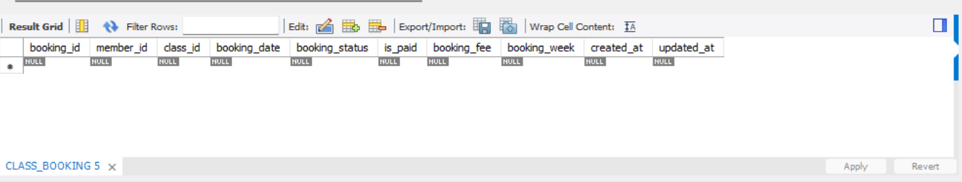
Figure 5 Class_Booking table creation

Table 6: FACILITY_BOOKING
CREATE TABLE FACILITY_BOOKING (
facility_booking_id INT AUTO_INCREMENT PRIMARY KEY,
member_id INT NOT NULL,
facility_id INT NOT NULL,
booking_date DATE NOT NULL,
start_time TIME NOT NULL,
end_time TIME NOT NULL,
activity_name VARCHAR(100) NOT NULL,
booking_status ENUM('CONFIRMED', 'CANCELLED') DEFAULT 'CONFIRMED',
number_of_attendees INT NOT NULL,
booking_week INT GENERATED ALWAYS AS (WEEK(booking_date)) STORED,
created_at TIMESTAMP DEFAULT CURRENT_TIMESTAMP,
updated_at TIMESTAMP DEFAULT CURRENT_TIMESTAMP ON UPDATE CURRENT_TIMESTAMP,
FOREIGN KEY (member_id) REFERENCES MEMBER(member_id),
FOREIGN KEY (facility_id) REFERENCES FACILITY(facility_id),
UNIQUE KEY unique_member_facility_week (member_id, booking_week),
CHECK (end_time > start_time),
CHECK (TIMEDIFF(end_time, start_time) <= '02:00:00'),
CHECK (number_of_attendees > 0),
INDEX idx_member_id (member_id),
INDEX idx_facility_id (facility_id),
INDEX idx_booking_date (booking_date),
INDEX idx_booking_week (booking_week),
INDEX idx_facility_date_time (facility_id, booking_date, start_time, end_time)
) ENGINE=InnoDB DEFAULT CHARSET=utf8mb4 COLLATE=utf8mb4_unicode_ci;
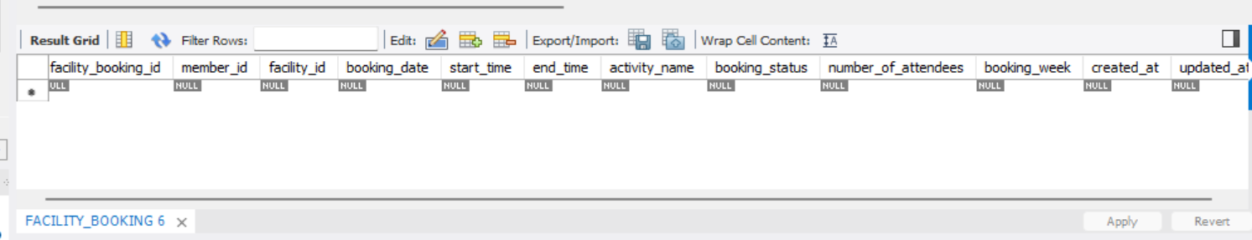
Figure 6 Facility_Booking table creation

Table 7: PAYMENT
CREATE TABLE PAYMENT (
payment_id INT AUTO_INCREMENT PRIMARY KEY,
member_id INT NOT NULL,
payment_amount DECIMAL(8,2) NOT NULL,
payment_date TIMESTAMP DEFAULT CURRENT_TIMESTAMP,
payment_type ENUM('WEEKLY_SUBSCRIPTION', 'EXTRA_CLASS', 'OTHER') NOT NULL,
payment_method ENUM('CASH', 'CARD', 'STANDING_ORDER') NOT NULL,
payment_status ENUM('PENDING', 'COMPLETED', 'FAILED') DEFAULT 'COMPLETED',
related_class_booking_id INT,
receipt_number VARCHAR(50) UNIQUE,
created_at TIMESTAMP DEFAULT CURRENT_TIMESTAMP,
updated_at TIMESTAMP DEFAULT CURRENT_TIMESTAMP ON UPDATE CURRENT_TIMESTAMP,
FOREIGN KEY (member_id) REFERENCES MEMBER(member_id),
FOREIGN KEY (related_class_booking_id) REFERENCES CLASS_BOOKING(booking_id),
CHECK (payment_amount > 0),
INDEX idx_member_id (member_id),
INDEX idx_payment_date (payment_date),
INDEX idx_payment_type (payment_type),
INDEX idx_class_booking_id (related_class_booking_id)
) ENGINE=InnoDB DEFAULT CHARSET=utf8mb4 COLLATE=utf8mb4_unicode_ci;
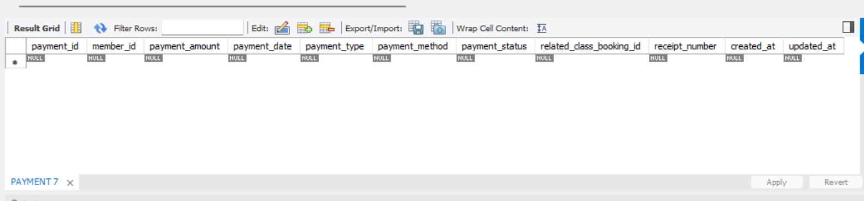
Figure 7 Payment table creation

Insert Data

Members
INSERT INTO MEMBER
(first_name, surname, address, telephone_number, email_address, date_of_birth, medical_conditions, membership_start_date, membership_end_date, membership_status)
VALUES
('Swodesh','Singh','Kathmandu','9823657843','SwodeshSingh@email.com','1995-05-10','None','2024-01-01',NULL,'ACTIVE'),
('Adarsha','Chaulagai','Lalitpur','9834672345','adarsha@email.com','1998-08-15','Asthma','2024-02-01',NULL,'ACTIVE'),
('Himal','Adhikari','Bhaktapur','9836578456','AdhikariHimal@email.com','1992-12-20','Knee Injury','2024-03-01',NULL,'ACTIVE');
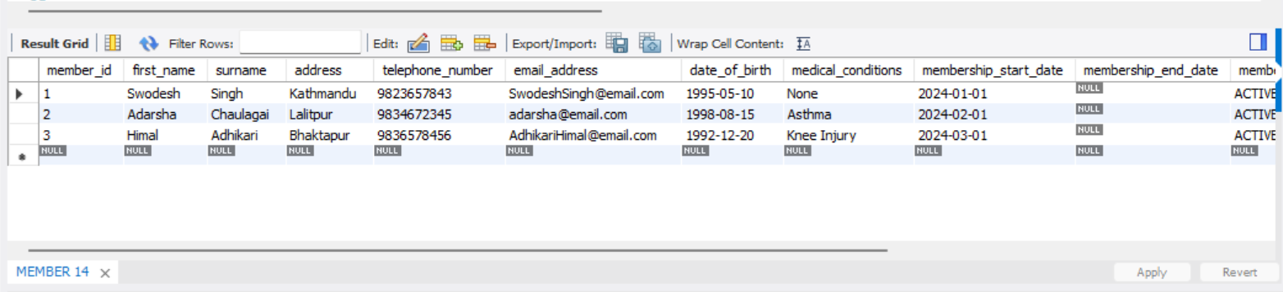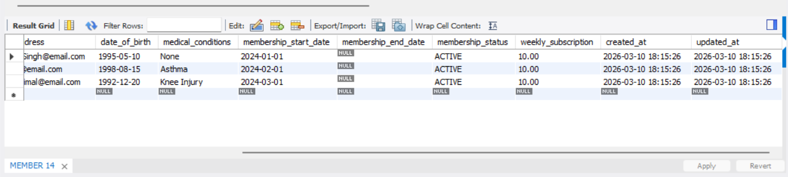
Figure 8 Values inserted in Member

Staff

INSERT INTO STAFF
(first_name, surname, role, contact_phone_number, employment_start_date)
VALUES
('Ram','Bhakta','Personal Trainer','9834556232','2023-01-10'),
('Shyam','Bahadur','Class Instructor','9836451287','2023-02-15'),
('Yudesh','Maharjan','Manager','9843333333','2022-05-20');
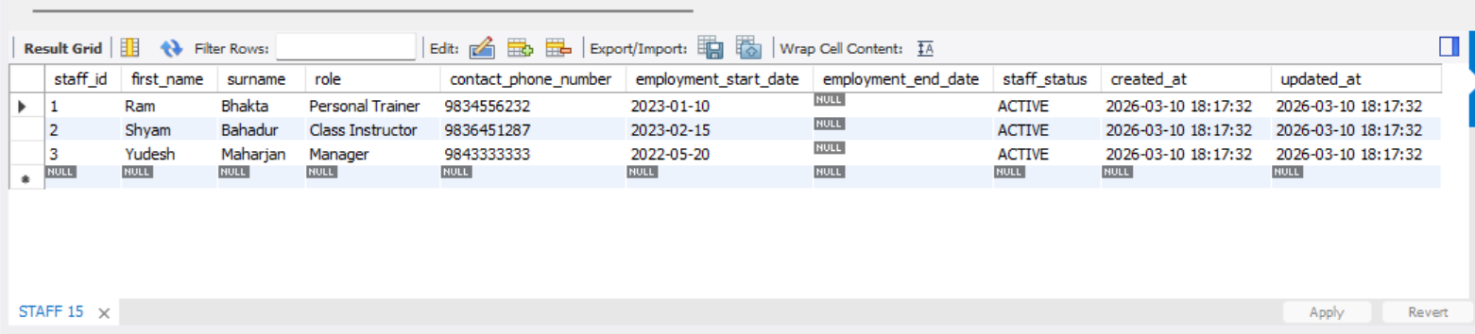
Figure 9 Values inserted in Staff

Facility
INSERT INTO FACILITY
(facility_name, maximum_capacity, facility_description)
VALUES
('Main Gym Floor',50,'General gym equipment area'),
('Yoga Studio',20,'Quiet room for yoga and stretching classes'),
('Swimming Pool',30,'Indoor heated swimming pool');
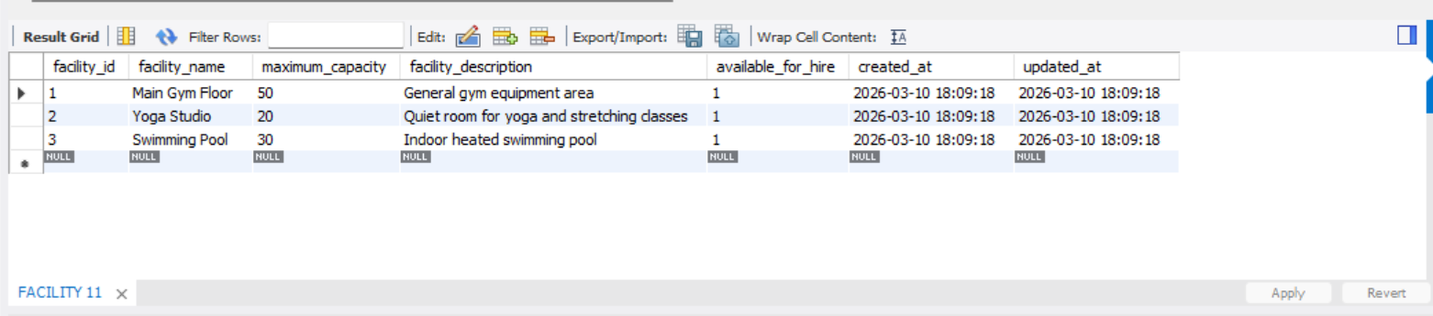
Figure 10 Values inserted in Facility

Class
INSERT INTO CLASS
(class_name, instructor_id, day_of_week, start_time, end_time, maximum_class_size, class_description)
VALUES
('Morning Yoga',2,'Monday','08:00:00','09:00:00',20,'Relaxing yoga class'),
('HIIT Training',1,'Wednesday','17:00:00','18:00:00',15,'High intensity interval training'),
('Evening Pilates',2,'Friday','18:30:00','19:30:00',18,'Pilates core training');
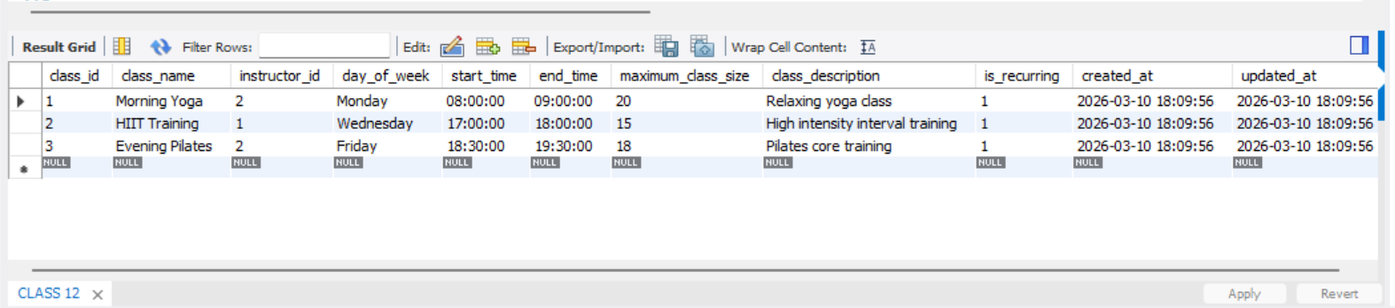
Figure 11 Values inserted in Class

CLASS_BOOKING
INSERT INTO CLASS_BOOKING
(member_id, class_id, booking_date, booking_status, is_paid, booking_fee)
VALUES
(1,1,'2024-06-10','CONFIRMED',TRUE,0.00),
(2,2,'2024-06-11','CONFIRMED',TRUE,5.00),
(3,3,'2024-06-12','CONFIRMED',FALSE,5.00);
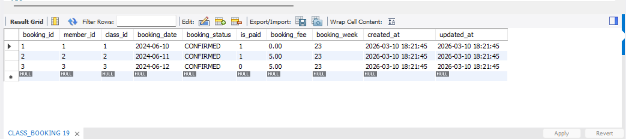
Figure 12 Values inserted in Class_Booking

FACILITY_BOOKING
INSERT INTO FACILITY_BOOKING
(member_id, facility_id, booking_date, start_time, end_time, activity_name, number_of_attendees)
VALUES
(1,1,'2024-06-15','10:00:00','11:30:00','Personal Workout',1),
(2,2,'2024-06-16','09:00:00','10:30:00','Yoga Practice',5),
(3,3,'2024-06-17','14:00:00','15:30:00','Swimming Training',3);
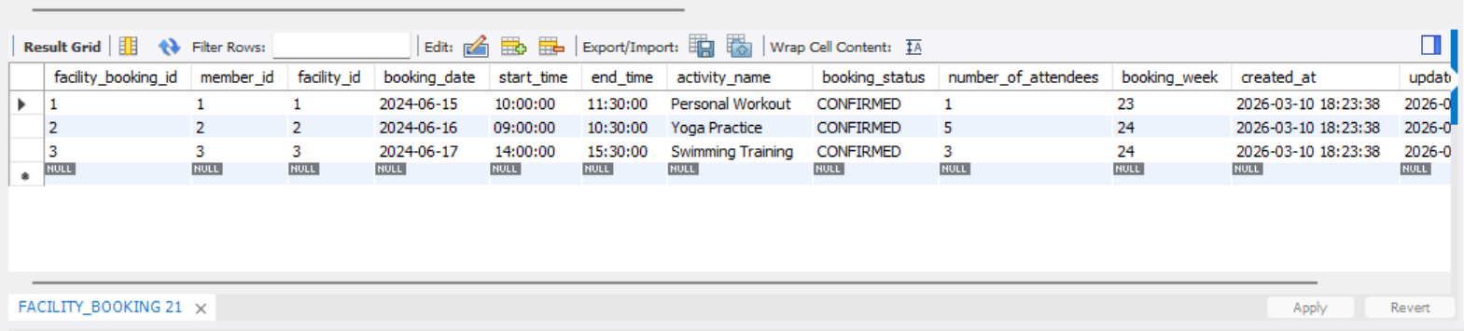
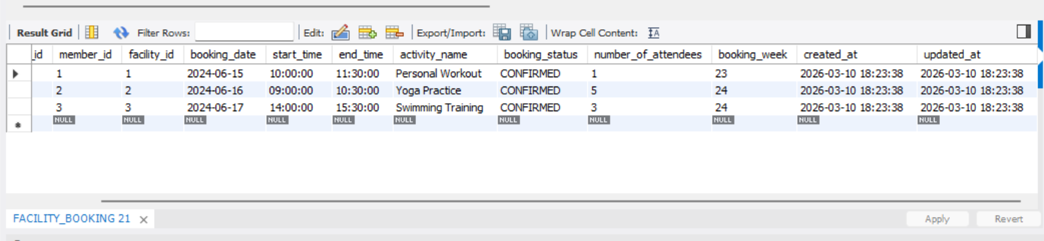
Figure 13 Values inserted in Facility_Booking

Payment
INSERT INTO PAYMENT
(member_id, payment_amount, payment_type, payment_method, related_class_booking_id, receipt_number)
VALUES
(1,10.00,'WEEKLY_SUBSCRIPTION','CARD',1,'RCPT001'),
(2,5.00,'EXTRA_CLASS','CASH',2,'RCPT002'),
(3,10.00,'WEEKLY_SUBSCRIPTION','STANDING_ORDER',3,'RCPT003');
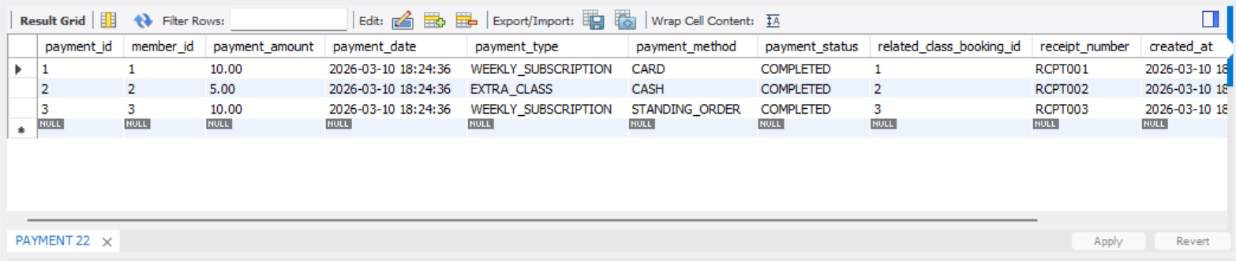
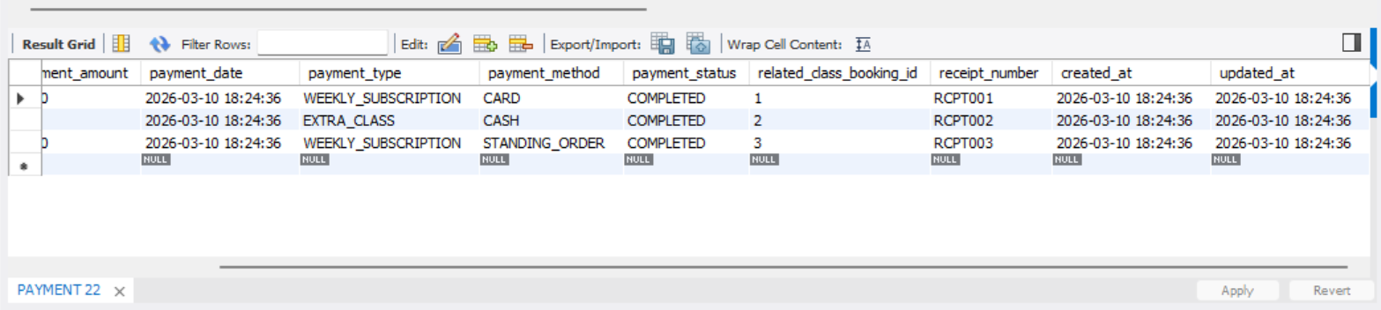
Figure 14 Values inserted in Payment

Query Design and Implementation

List of Queries Purpose
# | Query Purpose
Q1 | List all active members
Q2 | Show all classes taught by a specific instructor
Q3 | Count the number of bookings per class
Q4 | Find members who have booked classes in a given week
Q5 | List all facility bookings for a given week
Q6 | Calculate total revenue by payment type
Q7 | Retrieve classes that still have availability
Table 9 Querry purpose

Querry1

SELECT member_id, first_name, surname, email_address
FROM MEMBER
WHERE membership_status = 'ACTIVE';
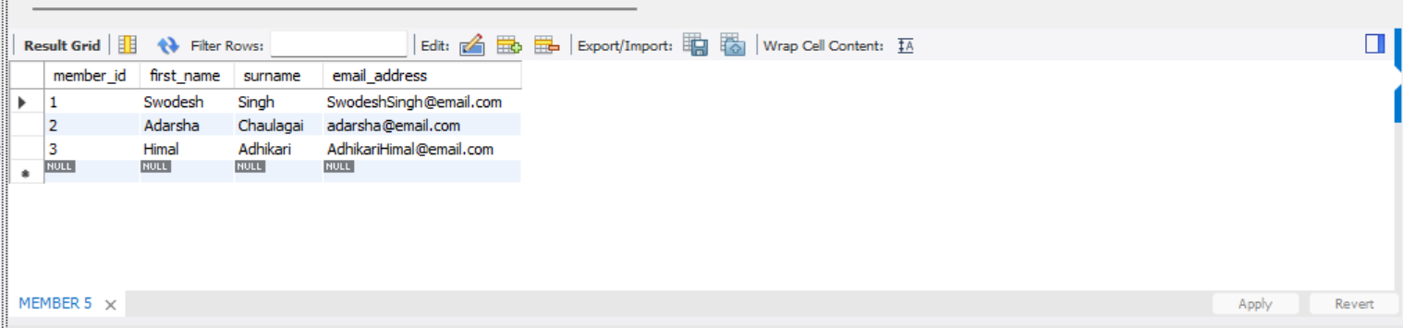
Figure 15 Querry: List all active members

Querry2
SELECT class_id, class_name, day_of_week, start_time, end_time
FROM CLASS
WHERE instructor_id = 2;
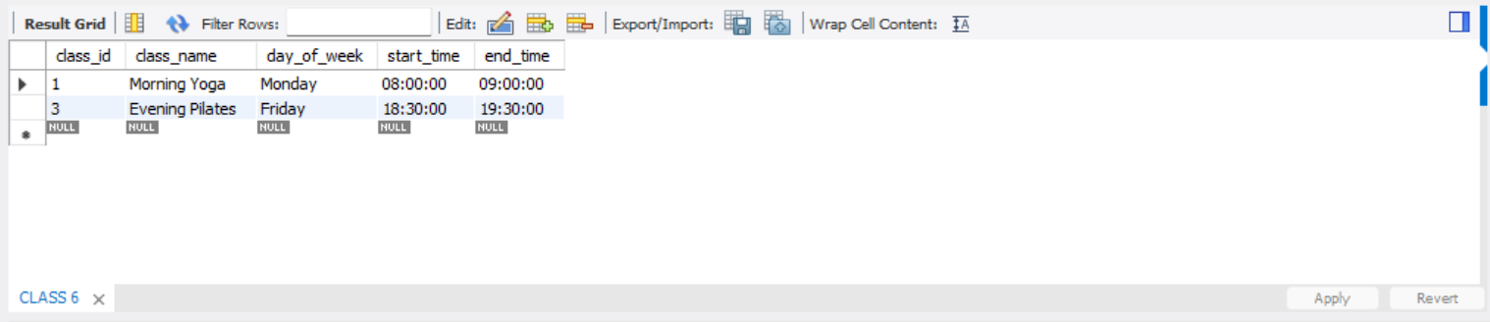
Figure 16 Querry: Show all classes taught by a specific instructor

Querry3
SELECT c.class_name, COUNT(cb.booking_id) AS total_bookings
FROM CLASS c
LEFT JOIN CLASS_BOOKING cb
ON c.class_id = cb.class_id
AND cb.booking_status = 'CONFIRMED'
GROUP BY c.class_id, c.class_name;
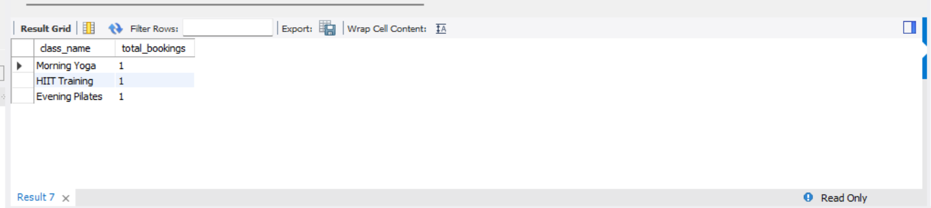
Figure 17 Querry: Count the number of bookings per class

Querry4
SELECT m.member_id, m.first_name, m.surname,
COUNT(cb.booking_id) AS classes_booked
FROM MEMBER m
JOIN CLASS_BOOKING cb ON m.member_id = cb.member_id
WHERE cb.booking_status = 'CONFIRMED'
AND cb.booking_date BETWEEN '2024-06-01' AND '2024-06-30'
GROUP BY m.member_id, m.first_name, m.surname;

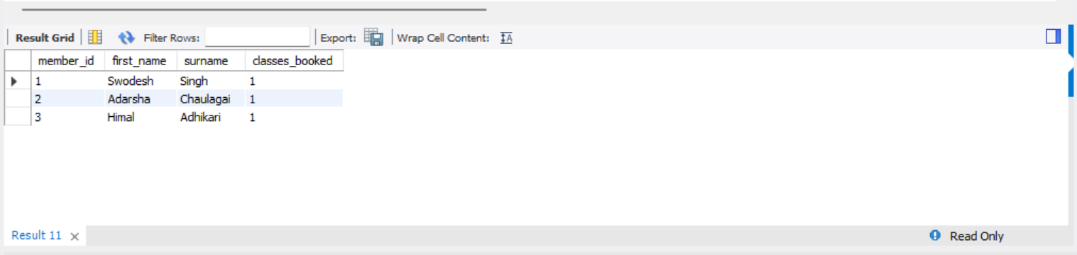
Figure 18 Querry: Find members who have booked classes in a given week

Querry5
SELECT fb.facility_booking_id, m.first_name, m.surname,
f.facility_name, fb.booking_date, fb.start_time, fb.end_time
FROM FACILITY_BOOKING fb
JOIN MEMBER m ON fb.member_id = m.member_id
JOIN FACILITY f ON fb.facility_id = f.facility_id
WHERE fb.booking_week = 24;
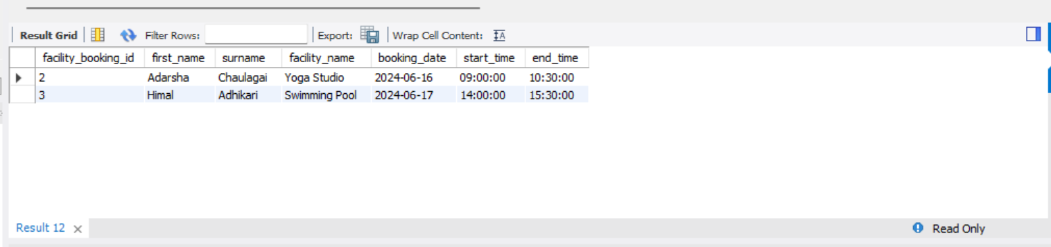
Figure 19 Querry: List all facility bookings for a given week

Querry6
SELECT payment_type, SUM(payment_amount) AS total_revenue
FROM PAYMENT
WHERE payment_status = 'COMPLETED'
GROUP BY payment_type;
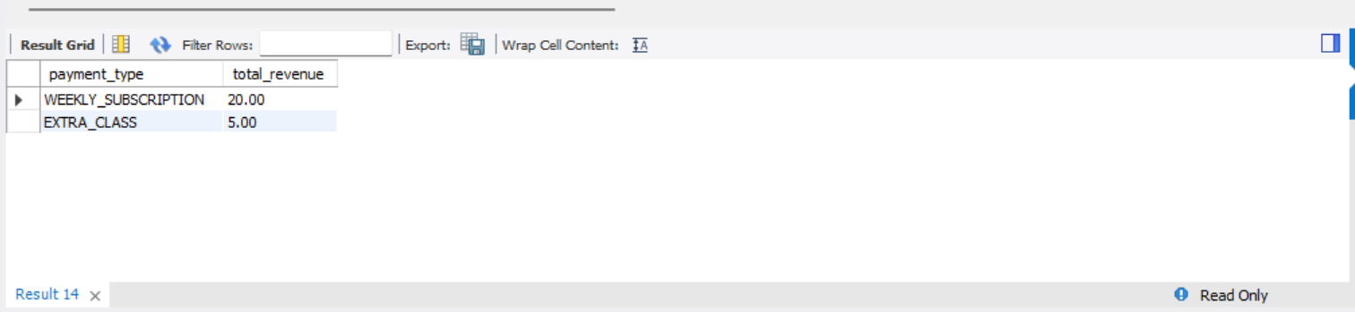
Figure 20 Querry: Calculate total revenue by payment type

Querry7
SELECT c.class_id, c.class_name, c.maximum_class_size,
COUNT(cb.booking_id) AS booked_spaces,
(c.maximum_class_size - COUNT(cb.booking_id)) AS spaces_left
FROM CLASS c
LEFT JOIN CLASS_BOOKING cb
ON c.class_id = cb.class_id
AND cb.booking_status = 'CONFIRMED'
GROUP BY c.class_id, c.class_name, c.maximum_class_size
HAVING COUNT(cb.booking_id) < c.maximum_class_size;

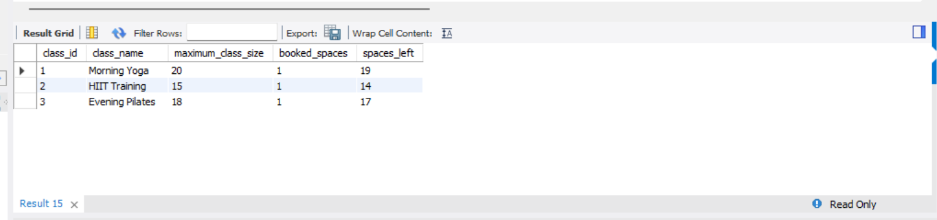
Figure 21 Querry: Retrieve classes that still have availability

Discussion / Critical Reflection
The design challenges involved were the enforcement of the five free bookings per week policy, which required the use of the generated column, booking_week, for aggregation, although triggers or application logic would be more appropriate. Also, the enforcement of no double bookings of facilities requires time-overlap checks, which would be best achieved with BEFORE INSERT triggers. The use of ENUM data types ensured data integrity for the status fields.
The schema follows the rules of the Third Normal Form (3NF), which means that the non-key attributes are dependent only on the primary key. Some relationships are also optional, as shown in the Payment table with the related_class_booking_id. Additional tables, such as the Membership_Plan and Attendance tables, could be included.

Conclusion
This project is used to demonstrate the design and implementation of a relational database system for Aspire Fitness. The database architecture is used for the basic operations associated with managing members, classes, bookings, and payments. The challenges faced are those associated with managing the bookings and avoiding conflicts. The design is normalized and results in a working database system for the scenario provided.

